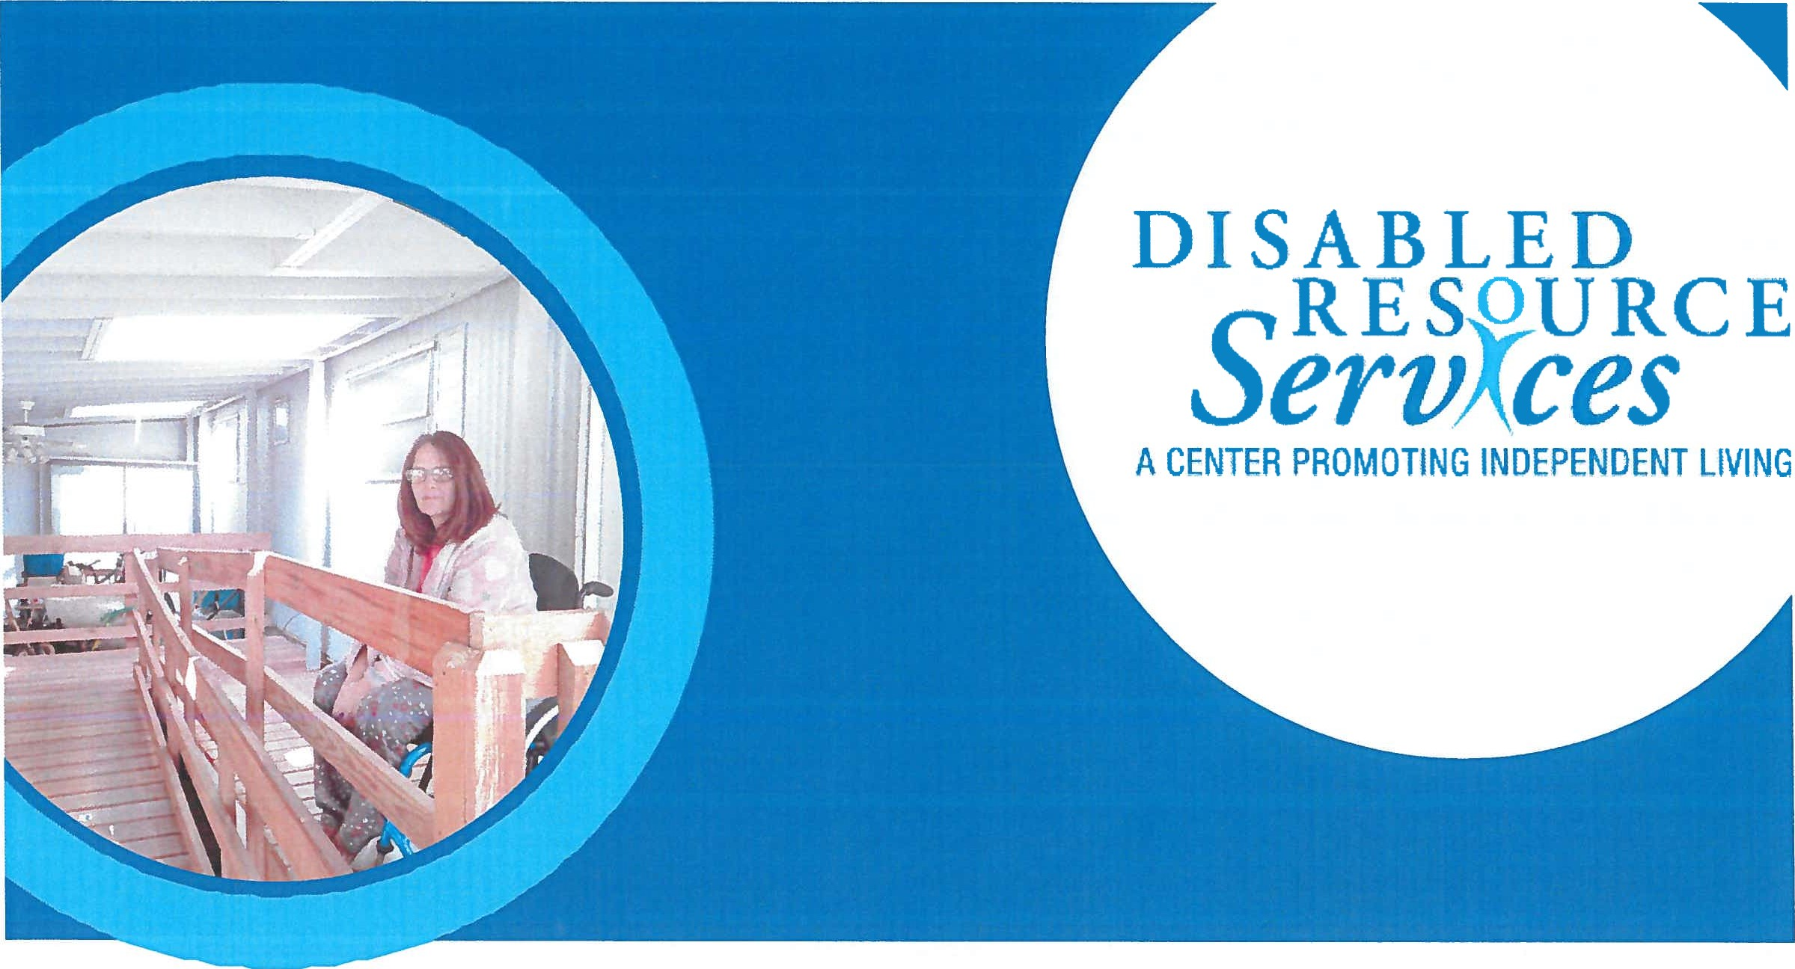
Marj Grell
[Company name] [Company address]2024
CONSUMER
SATISFACTION
REPORT

[Document title]

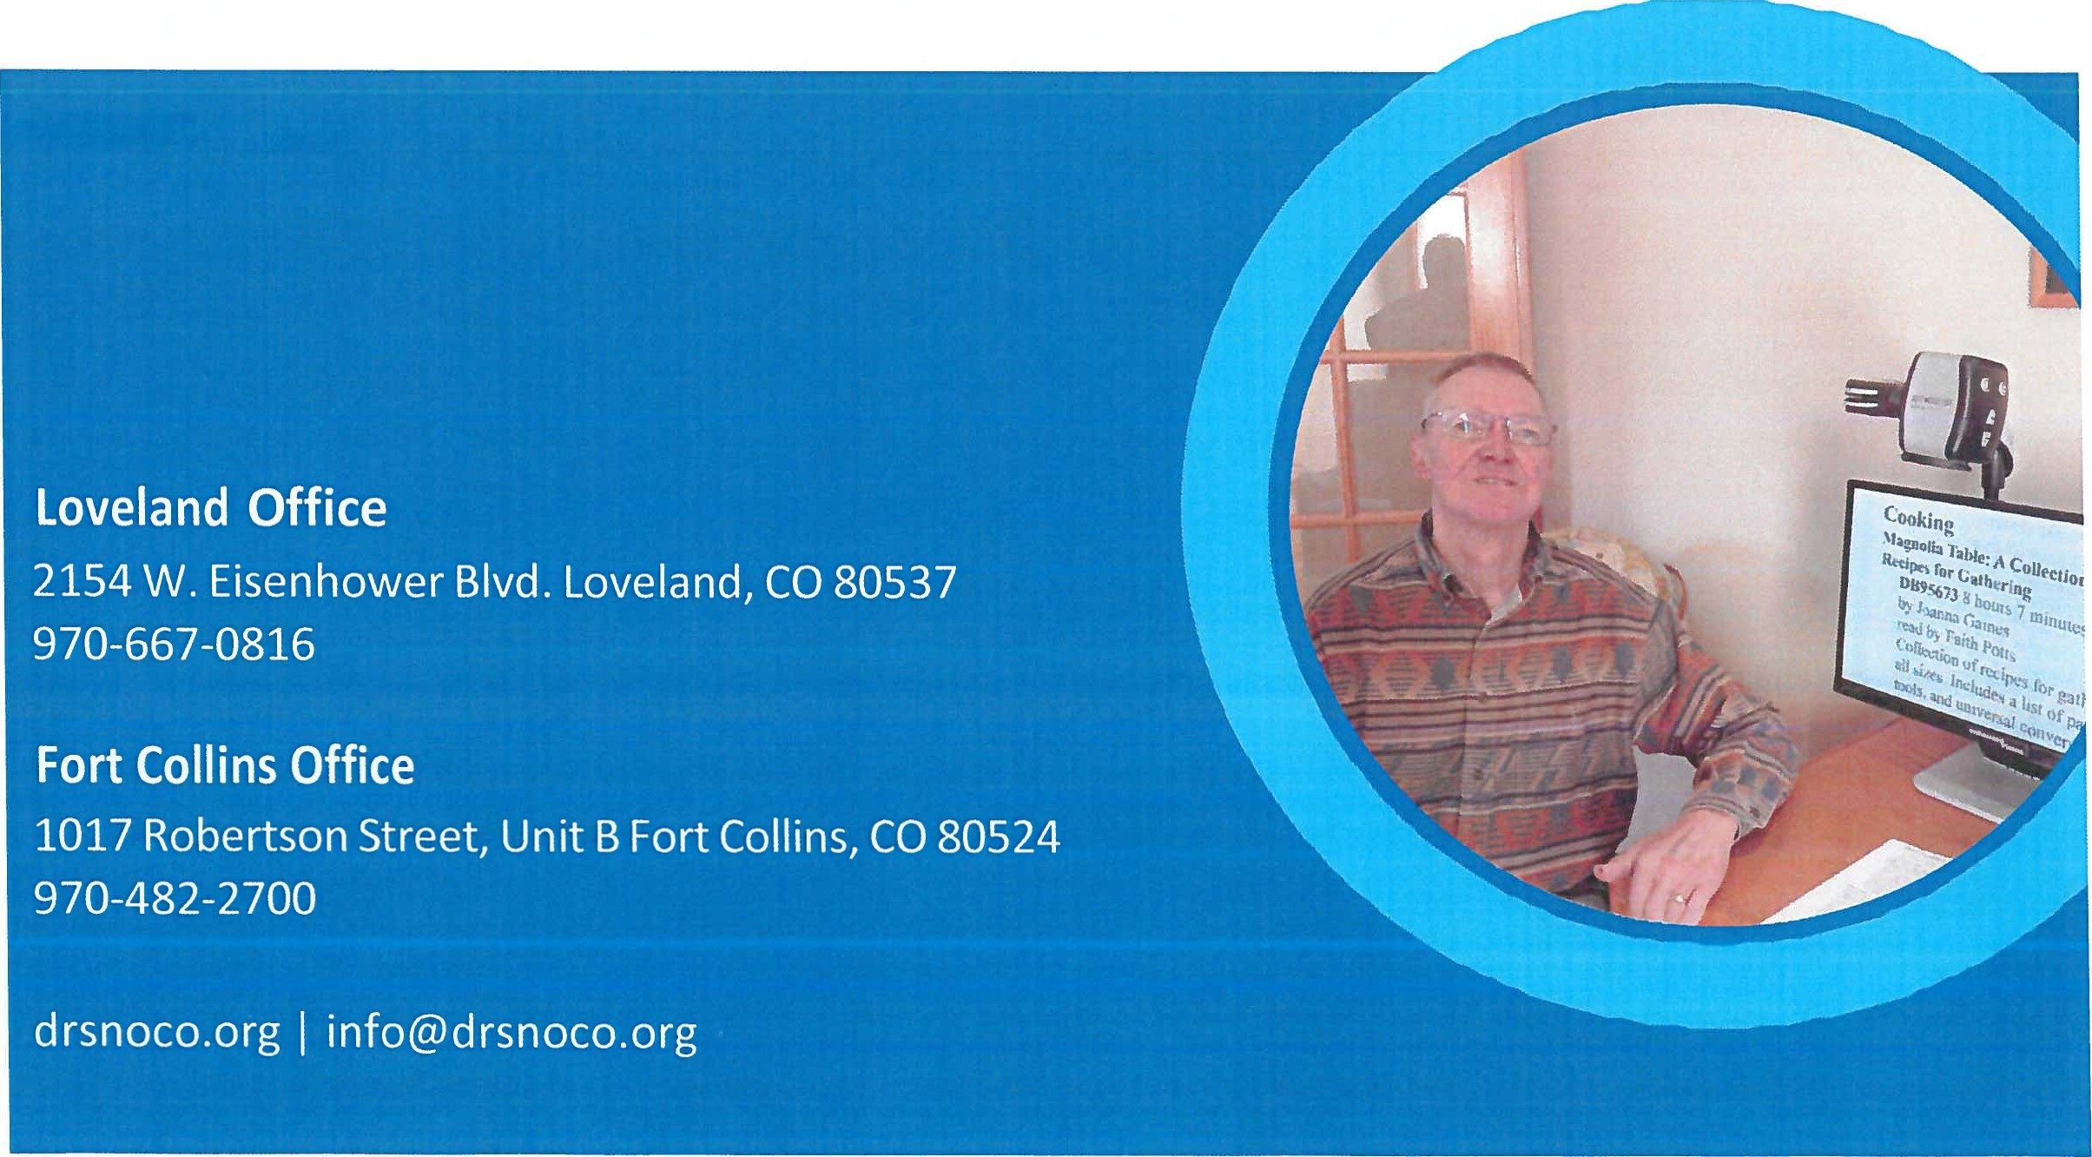

Combined Fort Collins and Loveland N=126
When receiving service from Disabled Resource Services, did you feel like you were in control over the goals you included in your Independent Living Plan?
Yes-89.68%, Somewhat-1.59%, No-8.73%

Was it easy to access services at Disabled Resource Services?
Yes-86.51%, Somewhat-.79%, No-12.7%

Would you recommend Disabled Resource Services to others?
Yes-88.1%, Somewhat/Maybe-1.59%, No-10.32%

Has working with Disabled Resource Services helped you to be more independent?
Yes-67.46%, Somewhat-6.35%, No-26.19%

After working with Disabled Resource Services, do you feel like your community is more inclusive for people with disabilities?
Yes-38.1%, Somewhat-55.56%, No-6.35%

Do you feel like you are making a difference in changing the way others view disabilities?
Yes-69.84%, Somewhat-6.35%, No-23.81%

Are you able to live more independently since working with DRS?
Yes-60.32%, Somewhat-6.35%, No-33.33%
Have you become more self-reliant and self-sufficient since working with DRS?
Yes-63.49%, Somewhat-7.14%, No-29.37%

Are you better equipped to be your own self-advocate after working with DRS?
Yes-78.57%, Somewhat-4.76%, No-16.67%

Overall, how satisfied are you with the services that you received at Disabled Resource Services?
Very Satisfied-73.81%
Somewhat Satisfied-9.52%
Dissatisfied-16.67%

Fort Collins N=58
When receiving service from Disabled Resource Services, did you feel like you were in control over the goals you included in your Independent Living Plan?
Yes-89.66%, Somewhat-0%, No-10.34%

Was it easy to access services at Disabled Resource Services?
Yes-84.48%, Somewhat-1.72%, No-13.79%

Would you recommend Disabled Resource Services to others?
Yes-87.93%, Somewhat/Maybe-0%, No-12.07%

Has working with Disabled Resource Services helped you to be more independent?
Yes-72.41%, Somewhat-1.72%, No-25.86%

After working with Disabled Resource Services, do you feel like your community is more inclusive for people with disabilities?
Yes-41.38%, Somewhat-53.45%, No-5.17%

Do you feel like you are making a difference in changing the way others view disabilities?
Yes-65.52%, Somewhat-5.17%, No-29.31%

Are you able to live more independently since working with DRS?
Yes-67.24%, Somewhat-1.72%, No-31.03%

Have you become more self-sufficient/self-reliant since working with Disabled Resource Services?
Yes-70.69%, Somewhat-1.72%, No-27.59%

Are you better equipped to be your own self-advocate after working with DRS?
Yes-75.86%, Somewhat-5.17%, No-18.97%

Overall, how satisfied are you with the services you received from Disabled Resource Services?
Very Satisfied-74.14%
Somewhat Satisfied-12.07%
Unsatisfied-13.79%

Loveland N=68
When receiving service from Disabled Resource Services, did you feel like you were in control over the goals you included in your Independent Living Plan?
Yes-89.71%, Somewhat-2.94%, No-7.35%

Was it easy to access services at Disabled Resource Services?
Yes-88.24%, Somewhat-2.94%, No-8.82%

Would you recommend Disabled Resource Services to others?
Yes-88.24%, Somewhat/Maybe-2.94%, No-8.82%

Has working with Disabled Resource Services helped you to be more independent?
Yes-63.24%, Somewhat-10.29%, No-26.47%

After working with Disabled Resource Services, do you feel like your community is more inclusive for people with disabilities?
Yes-35.29%, Somewhat-58.82%, No-5.88%

Do you feel like you are making a difference in changing the way others view disabilities?
Yes-73.53%, Somewhat-7.35%, No-19.12%

Are you able to live more independently since working with DRS?
Yes-54.41%, Somewhat-10.29%, No-35.29%

Have you become more self-sufficient/self-reliant since working with Disabled Resource Services?
Yes-57.35%, Somewhat-10.29%, No-32.35%

Are you better equipped to be your own self-advocate after working with DRS?
Yes-80.88%, Somewhat-4.41%, No-14.71%

Overall, how satisfied are you with the services you received from Disabled Resource Services?
Very Satisfied-73.53%
Somewhat Satisfied-7.35%
Unsatisfied-19.12%

Consumer Comments
“She was awesome; followed through with everything; patient and knowledgeable.”
“She was very helpful and not judgmental.”
“Case manager helped me improve my life; she was great.”
“She was wonderful and helped me out a lot.”
“She was very nice and informative.”
“She was great-very nice and very professional.”
“She was very understanding, personable, nice to work with and I appreciated all her help.”
“She was easy to work with and eager to assist me with my needs.”
“She was great but there is only so much she can do if housing isn’t available.”
“She was very nice, and I liked working with her”
“She was very gracious and helped me get into housing.”
“She was great and knew what she was doing.”
“She is 5 stars out of 5; awesome to work with.”
“She made me very comfortable; I have told 4 people about DRS and will continue to do so; great to work with.”

